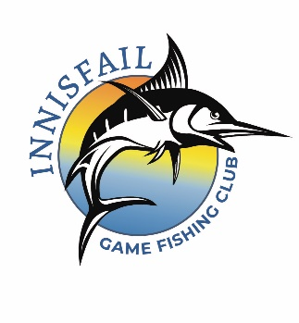
INNISFAIL GAME FISHING CLUB
MEMBERSHIP FORM
2023/24
The Membership Fee is $80.00 per senior angler and $40 per junior angler per year.

We understand that in acceptance of our enrolment application by the Innisfail Game Fishing Club Inc, we are required to abide by all the rules and conditions of enrolment, and amendments of those rules and conditions as issued from time to time, and do hereby agree to be bound by those conditions.

FULL NAME
RESIDENTIAL ADDRESS
POSTAL ADDRESS
HOME PHONE |  | MOBILE PHONE
EMAIL ADDRESS
So you can receive newsletters etc.
CATEGORY  (please circle) | SENIOR MALE, SENIOR FEMALE / JUNIOR MALE, JUNIOR FEMALE  Date of birth and age for Juniors only: …………………………………………
SIGNATURE
DATE

Payments are to be made to:
BANK | BENDIGO BANK INNISFAIL
BSB | 633 000 | ACCOUNT NO | 1136 48521
ACCOUNT NAME | INNISFAIL GAME FISHING CLUB
DATE PAID | AMOUNT PAID :

Email form with proof of payment (for EFT payments please use surname as reference)
or Send a cheque, with the completed form, to below address:
PLEASE NOTE: You are not a member until payment has been cleared and payment proof is received

Innisfail Game Fishing Club
PO Box 1036, Innisfail, Qld, 4860
Ph: 0400004837
Email: contact@igfc.com.au

